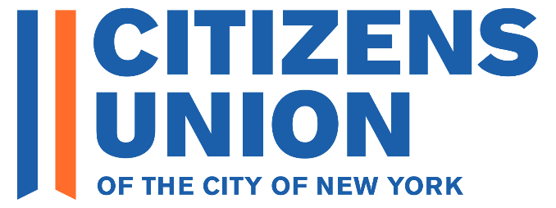
2025 Primary Candidate Questionnaire – New York City Comptroller

THIS IS A BLANK QUESTIONNAIRE – YOU CAN SEND IT WITH YOUR RESPONSES TO CANDIDATES@CITIZENSUNION.ORG OR SUBMIT IT ONLINE HERE

Congratulations to you on your decision to run for New York City Comptroller! Citizens Union appreciates your commitment to serving the public.

For over 125 years, Citizens Union (CU) has been devoted to holding our local government accountable with the highest ethical standards and fighting for political reforms that improve New York democracy (https://citizensunion.org/issues/). To promote a competitive and diverse political culture, a fair and open political process, and accountable and responsible government, we evaluate candidates running for office and back those who strongly support reform. Our evaluations are done through questionnaires, independent research, and interviews conducted by our Local Candidates Committee. (https://citizensunion.org/portfolio-item/citizens-union-2025-candidate-evaluation-info-for-candidates/).

As a prerequisite for receiving the support of Citizens Union, please complete the following questionnaire and submit your response by Sunday, April 6, 2025. As you complete the form, you can click “Save” and return to the form later. All responses have a 250-word limit. Once you have completed the questionnaire and submitted your response to us, you will receive a copy of your submission. Your submission will be posted on our website (with the exception of contact info).

Upon receipt of your submission, we will reach out to you or your staff to schedule a virtual interview with members of our Local Candidate Committee. The interview will not be recorded. Shortly thereafter, we will announce our support in key priority races to our members and on our website and other channels.

Please feel free to reach out to Citizens Union with any questions or comments at candidates@citizensunion.org.

Thank you very much. We look forward to your response.

GENERAL INFORMATION
Name
In which primary
Age
Education
Current job, position, or occupation
Other positions or offices
Previous jobs or positions
Contact information
Email
Campaign Manager Name
Campaign Manager Email
Phone Number
Website
X
Facebook
Instagram
Bluesky
Other social media platforms

INTRODUCTION
- What are your top three campaign promises or goals, and what action will you take to achieve them if elected?

- What experience have you had with good government and reform issues? (e.g., voting and election reform, campaign finance, ethics, police accountability, government transparency). If you've worked to advance these goals, we'd love to hear about it.

ELECTIONS AND VOTING
- Voter turnout in New York City elections is exceptionally low, as they are held “off-cycle” in odd-numbered years. To boost local voter turnout and reduce participation gaps, the Legislature passed, and Governor Hochul signed, a law that moves county and town elections to even-numbered years, and lawmakers are supporting a constitutional amendment that would do the same for city elections, including New York City’s. Citizens Union is leading a coalition of groups advocating to move New York City’s elections to even-numbered years, and the City Council is considering a Resolution in support of that shift.
Do you support moving New York City's elections from odd-numbered years to even-numbered years, and will you publicly support efforts in Albany to implement this reform?

YES/NO:
Comment (optional):

- New York City is one of the few cities that maintains a closed primary system, in which only registered party members can vote in the primary election. Do you believe New York City should shift to a form of completely open primaries, allowing all registered voters to vote in one primary where the top two candidates, regardless of party affiliation, move on to the general election?
YES/NO:
Comment (optional):

* In the box below, you may provide additional information on any actions that you have taken or plan to take to improve elections and voting in New York City.

ETHICS AND ACCOUNTABLITY IN GOVERNMENT
- The recent indictments and resignations surrounding City Hall have exposed serious ethical problems in City Government. As the City’s budget watchdog, what would you do to fight corruption and misuse of City funds?

- The City Comptroller is tasked with reviewing and registering City contracts and may present objections if the review process yields sufficient concern for corruption. Please describe your approach to reviewing contracts, and what areas in City Government procurement you believe most need attention to such issues?

- What would be your auditing priorities? What agencies and departments would you audit first?
* In the box below, you may provide additional information on any actions that you have taken or plan to take to improve ethics and accountability in New York City government.

PUBLIC PENSION FUNDS
- Comptrollers Stringer and Lander implemented various strategies for responsible investing, like fossil fuel divestment and shareholder advocacy. Do you agree with that approach, and if so, how do you propose to balance maximizing investment returns with broader social responsibility goals? If not, what are the top investment priorities that the public pensions funds should focus on?

- How will you select asset managers, and what would you do to reduce conflicts of interest that can arise from firms seeking pension business?

BUDGET AND FISCAL HEALTH
- Threats from the federal government to reduce funding to states and local governments could have a dramatic effect on New York City. How would you utilize the authority of the Comptroller’s Office to ensure the fiscal health of our City, given these threats?

- The Trump administration has recently clawed back $80 million in previously allocated funds by the Federal Emergency Management Agency (FEMA), directly from City Government bank accounts. How would you protect the City’s budget in the face of these efforts to reverse duly appropriated federal funds to the City?

* In the box below, you may provide any additional information on any actions that you have taken or plan to take to improve the fiscal health and budget in New York City government.

ADDITIONAL INFO
- Please feel free to attach any additional information such as resume, campaign brochures, or issues statements.

- Please provide any other info you would like us to know about you and your candidacy.

