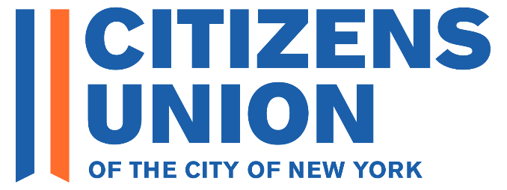
2025 Primary Candidate Questionnaire – Borough President

THIS IS A BLANK QUESTIONNAIRE – YOU CAN SEND IT WITH YOUR RESPONSES TO CANDIDATES@CITIZENSUNION.ORG OR SUBMIT IT ONLINE HERE

Congratulations to you on your decision to run for Borough President! Citizens Union appreciates your commitment to serving the public.

For over 125 years, Citizens Union (CU) has been devoted to holding our local government accountable with the highest ethical standards and fighting for political reforms that improve New York democracy (https://citizensunion.org/issues/). To promote a competitive and diverse political culture, a fair and open political process, and accountable and responsible government, we evaluate candidates running for office and back those who strongly support reform. Our evaluations are done through questionnaires, independent research, and interviews conducted by our Local Candidates Committee. (https://citizensunion.org/portfolio-item/citizens-union-2025-candidate-evaluation-info-for-candidates/).

As a prerequisite for receiving the support of Citizens Union, please complete the following questionnaire and submit your response by Sunday, April 6, 2025. As you complete the form, you can click “Save” and return to the form later. All responses have a 250-word limit. Once you have completed the questionnaire and submitted your response to us, you will receive a copy of your submission. Your submission will be posted on our website (with the exception of contact info).

Upon receipt of your submission, we will reach out to you or your staff to schedule a virtual interview with members of our Local Candidate Committee. The interview will not be recorded. Shortly thereafter, we will announce our support in key priority races to our members and on our website and other channels.

Please feel free to reach out to Citizens Union with any questions or comments at candidates@citizensunion.org.

Thank you very much. We look forward to your response.

GENERAL INFORMATION
Name
In which primary
Age
Education
Current job, position, or occupation
Other positions or offices
Previous jobs or positions
Contact information
Email
Campaign Manager Name
Campaign Manager Email
Phone Number
Website
X
Facebook
Instagram
Bluesky
Other social media platforms

INTRODUCTION
- What are your top three campaign promises or goals, and what action will you take to achieve them if elected?

- What experience have you had with good government and reform issues? (e.g., voting and election reform, campaign finance, ethics, police accountability, government transparency). If you've worked to advance these goals, we'd love to hear about it.

ELECTIONS AND VOTING
- Voter turnout in New York City elections is exceptionally low, as they are held “off-cycle” in odd-numbered years. To boost local voter turnout and reduce participation gaps, the Legislature passed, and Governor Hochul signed, a law that moves county and town elections to even-numbered years, and lawmakers are supporting a constitutional amendment that would do the same for city elections, including New York City’s. Citizens Union is leading a coalition of groups advocating to move New York City’s elections to even-numbered years, and the City Council is considering a Resolution in support of that shift.
Do you support moving New York City's elections from odd-numbered years to even-numbered years, and will you publicly support efforts in Albany to implement this reform?

YES/NO:
Comment (optional):

- New York City is one of the few cities that maintains a closed primary system, in which only registered party members can vote in the primary election. Do you believe New York City should shift to a form of completely open primaries, allowing all registered voters to vote in one primary where the top two candidates, regardless of party affiliation, move on to the general election?
YES/NO:
Comment (optional):

* In the box below, you may provide additional information on any actions that you have taken or plan to take to improve elections and voting in New York City.

ETHICS AND ACCOUNTABLITY IN GOVERNMENT
- The recent indictments and resignations surrounding City Hall have exposed serious ethical problems in City Government. Borough Presidents are involved in land use projects, where the nexus of money and lobbying is most apparent. Given that role, please describe how you will maintain the highest ethical standards in office.

- Borough Presidents allocate funding for capital projects in their borough and provide grants to nonprofits. For incumbents: are the projects and organizations receiving such funding made public and are accessible on your website every year? For non-incumbents: How would you ensure transparency of capital and discretionary funding as Borough President?

* In the box below, you may provide additional information on any actions that you have taken or plan to take to improve ethics and accountability in New York City government.

PLANNING AND LAND USE
- Please describe the most pressing land use issues in your borough and what would you do, or have done, as borough president to address them?

- Do you believe the borough president’s role in land use and zoning processes should change? If so, what role you believe the Borough President should have?

- As Borough President, how would you balance the interests of specific community boards and the borough-wide housing needs in your land use recommendations?

COMMUNITY BOARD AND APPOINTMENTS
- Borough presidents are charged with making hundreds of appointments. What criteria would you use for appointments to positions appointed by the borough president (the Panel on Educational Policy, City Planning Commission, community boards, etc.)? What processes would you put in place for advertising open positions and recruiting qualified candidates, and how would you assure that appointments represent the diversity of the borough’s neighborhoods?

- Borough presidents are charged with providing training and assistance to community boards on land use issues. How would you use the office to help community boards fulfill their charter mandated responsibilities to provide feedback on land use proposals, while enabling the boards to make decisions independent of the borough president’s office?

* In the box below, you may provide any additional information on any actions that you have taken or plan to take to improve the work of community boards in New York City government.

ADDITIONAL INFO
- Please feel free to attach any additional information such as resume, campaign brochures, or issues statements.

- Please provide any other info you would like us to know about you and your candidacy.

